GHANA COMMUNICATION TECHNOLOGY
UNIVERSITY


FACULTY OF COMPUTING AND INFORMATION
SYSTEMS

DEPARTMENT OF INFORMATION TECHNOLOGY

TITLE:
DESIGNING AND IMPLEMENTATION OF AN INTELLIGENT
CREDIT CARD FRAUD DETECTION SYSTEM USING
MACHINE LEARNING AND DEEP LEARNING TECHNIQUES.

BY:
FRANCIS WILFRED ENIMIL ASHUN – 1724941254
JEFFREY APPIAH DANKWA – 1725535951
SELASI MORICA APAU – 1727845398
SUPERVISOR:
Name: DR. JOHN KANI AMOAKO.

MARCH,2026.

ACKNOWLEDGEMENT

I would like to express my heartfelt gratitude to my supervisor, Dr. John Kani Amoako, for the guidance, patience, and constructive feedback provided
throughout every stage of this project. Their insight was especially valuable
in shaping the structure and direction of this documentation, and in pushing
me to think more carefully about the real-world reliability of the system I
built rather than settling for a version that merely appeared to work.

I am also thankful to the entire faculty at Ghana Communications Technology
University for the foundation in software development and machine
learning principles that made this project possible. The knowledge gained
throughout my studies directly informed the technical decisions made in
designing NonFraud-AI, from the choice of a hybrid rule-based and machine
learning architecture to the iterative debugging process that materially
improved the reliability of its predictions.

My appreciation also extends to my classmates and peers, whose willingness to
discuss ideas, test the system, and offer honest feedback helped surface
issues I would otherwise have missed. Their perspective, often from outside
the immediate technical details, proved genuinely useful in refining both the
system and this report.

Finally, I owe a deep debt of gratitude to my family and friends, whose
patience, encouragement, and steady support carried me through the more
demanding stretches of this project, particularly as deadlines approached.
Their belief in my ability to see this through mattered more than they
likely realize.

ACKNOWLEDGEMENT 2
CHAPTER ONE 7
INTRODUCTION 7
1.1 Background to the Study 7
1.2 Statement of the Problem 7
1.3 Purpose of the Study 7
1.4 Objectives of the Study 8
1.4.1 General Objective 8
1.4.2 Specific Objectives 8
1.5 Research Questions 8
1.6 Significance of the Study 9
1.7 Delimitations of the Study 9
1.8 Limitations of the Study 9
1.9 Definition of Terms 9
1.10 Organization of the Rest of the Study 10
CHAPTER TWO 11
LITERATURE REVIEW 11
2.1 Introduction 11
2.2 Overview of Relevant Literature 11
2.2.1 Traditional Rule-Based Fraud Detection Systems 11
2.2.2 Machine Learning Approaches to Fraud Detection 11
2.2.3 Hybrid Rule-ML Systems 11
2.2.4 Geolocation and Behavioral Features in Fraud Detection 11
2.2.5 Evaluation Metrics in Fraud Detection Research 11
2.3 Previous Studies and Related Works 12
2.3.1 Gap Identified in Existing Systems 12
2.4 Conclusion 12
CHAPTER THREE 13
METHODOLOGY 13
3.1 Introduction 13
3.2 Research and Development Approach 13
3.2.1 Justification for the Chosen Approach 13
3.3 System Development Life Cycle 13
3.3.1 Requirements Phase Methodology 14
3.3.2 Design Phase Methodology 14
3.3.3 Implementation Phase Methodology 14
3.3.4 Testing Phase Methodology 14
3.3.5 Evaluation and Refinement Methodology 15
3.4 Requirements Engineering Methodology 15
3.4.1 Requirements Gathering Techniques 15
3.4.2 Functional Requirements 15
3.4.3 Non-Functional Requirements 15
3.4.4 Use Case Analysis Methodology 16
3.5 Data Methodology 16
3.5.1 Justification for Synthetic Data Generation 16
3.5.2 Feature Selection Methodology 16
3.5.3 Synthetic Dataset Generation Process 17
3.6 Model Development Methodology 17
3.6.1 Algorithm Selection and Justification 17
3.6.2 Training Methodology 17
3.6.3 Rule-Based Override Methodology 17
3.7 Development Environment and Tools 18
3.8 Testing Methodology 18
3.8.1 Unit Testing Approach 18
3.8.2 Integration Testing Approach 18
3.8.3 System Testing Approach 19
3.8.4 Security Testing Approach 19
3.8.5 User Acceptance Testing Approach 19
3.9 Evaluation Methodology 19
3.9.1 Model Evaluation Metrics 19
3.9.2 System Evaluation Criteria 19
3.10 Chapter Summary 19
CHAPTER FOUR 21
SYSTEM DESIGN, IMPLEMENTATION AND TESTING 21
4.1 Introduction 21
4.2 System Architectural Design 21
4.3 Database Design 22
4.4 Use Case Design 23
4.5 Fraud Prediction Activity Design 25
4.6 User Interface Design 26
4.7 Security Design 27
4.8 Machine Learning Model Design 27
4.9 System Implementation Overview 28
4.10 Implementation of the Transaction Simulation Page 28
4.11 Implementation of the Fraud Prediction Engine 30
4.12 Implementation of Admin Authentication 30
4.13 Implementation of the Admin Dashboard 31
4.13.1 Overview and Metrics 31
4.13.2 Manual Flagging and Blacklist Management 32
4.13.3 Transaction Triage Log 32
4.14 Implementation of the Model Training Pipeline 33
4.15 Iterative Debugging and Refinement 34
4.15.1 Amount Feature Mismatch 34
4.15.2 Distance Feature Gaps 34
4.15.3 Hard Probability Cliff 35
4.15.4 Velocity Calculation Collision Bug 36
4.16 System Testing 36
4.16.1 Unit Testing 36
4.16.2 Integration Testing 37
4.16.3 System Testing 37
4.16.4 Security Testing 37
4.16.5 User Acceptance Testing (UAT) 37
4.17 System Evaluation 37
4.17.1 Evaluation Metrics 38
4.17.2 Performance Evaluation 38
4.18 Chapter Summary 38
CHAPTER FIVE 39
CONCLUSION AND RECOMMENDATIONS 39
5.1 Introduction 39
5.2 Discussion 39
5.2.1 Achievement of Objective One (Model Design) 39
5.2.2 Achievement of Objective Two (Web Application) 39
5.2.3 Achievement of Objective Three (Administrative Dashboard) 39
5.3 Key Achievements 39
5.4 Challenges Encountered 40
5.5 Recommendations 40
5.5.1 Integration with Real Payment Gateways 40
5.5.2 Mobile Application 40
5.5.3 Advanced Notification System 40
5.5.4 Improved Analytics 40
5.5.5 Enhanced Security 40
5.5.6 Cloud Deployment 40
5.5.7 Further Model Improvement 41
5.6 Conclusion 41
APPENDICES 42
APPENDIX A: USER MANUAL 42
A.1 Introduction 42
A.2 Running the Application 42
A.3 End User Guide 42
To screen a transaction, the host platform sends a POST request to: 42
/api/evaluate 42
With a JSON body containing: card_number, issuer_name, amount, 42
latitude, longitude 42
The response returns: risk_score_percentage, action (ALLOW/BLOCK), 42
and status 43
A.4 Administrator Guide 43
APPENDIX B: SAMPLE CODE LISTINGS 44
B.1 Haversine Distance Function 44
B.2 Database Schema Initialization 44
APPENDIX C: REQUIREMENTS GATHERING INSTRUMENT 45
REFERENCES 46

CHAPTER ONE

INTRODUCTION

Background to the Study

The global shift toward digital and card-based payments has been accompanied by a corresponding rise in credit card fraud (Cherif et al., 2023), ranging from card-not-present online fraud to card-cloning and account takeover schemes. Financial institutions and payment platforms increasingly rely on automated fraud detection systems to flag suspicious transactions in real time, since manual review cannot keep pace with the volume of transactions processed daily.
Two broad approaches dominate the fraud detection landscape (Marazqah Btoush et al., 2023). Rule-based systems apply fixed, human-defined thresholds and are transparent and easy to audit but are rigid and can be evaded once the rules are known. Machine learning (ML) based systems can detect subtler statistical patterns across many features simultaneously, but their decisions can be harder to explain and can behave unpredictably when the data they encounter in production differs from the data they were trained on.
NonFraud-AI was developed as a hybrid system that combines a supervised machine learning classifier (a Random Forest) with a small set of explicit business rules layered on top, aiming to capture the strengths of both approaches.

1.2 Statement of the Problem
Small and medium-sized platforms that wish to add fraud screening to their payment flow often face a difficult choice: adopt an expensive third-party fraud detection service, build a purely rule-based system that is easy to circumvent once its thresholds are known, or build a purely ML-based system that offers little transparency into why a transaction was flagged. There is a need for a lightweight, self-contained system that produces an interpretable risk score for each transaction, allows an administrator to review and override individual decisions, and supports manual blacklisting of known-bad cards, devices, or IP addresses.

1.3 Purpose of the Study
The purpose of this project is to design, build, and iteratively refine a working prototype of a hybrid fraud detection system for credit card transactions, complete with a transaction-simulation front end, a machine learning prediction engine, and an administrative dashboard for triage, flagging, and reporting.

1.4 Objectives of the Study

1.4.1 General Objective
To design and implement NonFraud-AI, a hybrid machine learning and rule-based system capable of assigning a real-time fraud risk score to simulated credit card transactions and supporting administrative review of flagged activity.

1.4.2 Specific Objectives
- To design a Random Forest classification model trained on transaction features (amount, hour of day, transaction velocity, distance from cardholder's registered home location, and distance from the card issuer's location).
- To implement a Flask-based web application that captures simulated transaction data and returns a fraud risk percentage in real time.
- To implement rule-based overrides for unambiguous high-risk conditions that operate alongside the ML model's output.
- To build an administrator dashboard supporting transaction triage, manual card/device flagging, and fraud reporting.
- To evaluate the trained model's classification performance and iteratively diagnose and correct sources of prediction error.

1.5 Research Questions
- What combination of transactional features best distinguishes fraudulent from legitimate transactions in a simulated environment?
- How should synthetic training data be generated so that it reflects the same feature distributions the system will encounter at inference time?
- What rule-based overrides, if any, should take precedence over the machine learning model's own output?
- How can prediction errors be diagnosed and traced back to specific weaknesses in the training data or feature engineering?

1.6 Significance of the Study
This project demonstrates, at prototype scale, how a hybrid detection architecture can be built with freely available tools without dependence on a commercial fraud-detection API. It also serves as a practical case study in diagnosing training-serving skew a common but often overlooked class of bug (Paleyes et al., 2022), in applied machine learning systems.

1.7 Delimitations of the Study
The system operates on simulated transaction data entered through a web form rather than live payment-network data, and does not integrate with an actual card payment gateway or banking API. Model training uses a programmatically generated synthetic dataset rather than a real, labelled fraud dataset.

1.8 Limitations of the Study
- The Random Forest model is trained entirely on synthetic data whose statistical properties approximate, but cannot perfectly replicate, real-world fraud patterns.
- The application uses SQLite, appropriate for a single-instance prototype but not for concurrent, multi-user production deployment.
- Geolocation is captured via the browser's Geolocation API and can be spoofed or denied by the end user.

1.9 Definition of Terms
Term | Definition
Fraud Risk Score | A percentage (0-100) output by the system representing the estimated likelihood that a transaction is fraudulent.
Velocity Count | The number of transactions made on the same card within a rolling one-hour window.
Haversine Formula | A formula used to calculate the great-circle distance between two points on a sphere, given their latitude and longitude.
Random Forest | An ensemble supervised machine learning algorithm that combines the predictions of many decision trees.
Training-Serving Skew | A discrepancy between the statistical distribution of data used to train a model and the distribution of data it receives once deployed.
Blacklisting | The administrative act of marking a card, device, or IP address as known-fraudulent.

1.10 Organization of the Rest of the Study
Chapter Two reviews relevant literature. Chapter Three presents the methodology followed during development. Chapter Four documents the system's design, its implementation, and its testing. Chapter Five discusses the extent to which the objectives were met and offers recommendations.

CHAPTER TWO

LITERATURE REVIEW

2.1 Introduction
This chapter reviews existing approaches to automated fraud detection, situating NonFraud-AI's hybrid design within the broader landscape of rule-based, machine-learning-based, and combined systems.

2.2 Overview of Relevant Literature

2.2.1 Traditional Rule-Based Fraud Detection Systems
Early fraud detection systems relied on fixed, expert-defined rules (Cherif et al., 2023). These systems are simple to implement and fully explainable, but rigid: fraudsters who learn the thresholds can structure transactions to fall just beneath them, and unusual-but-legitimate behavior can trigger a high false-positive rate.

2.2.2 Machine Learning Approaches to Fraud Detection
Supervised learning models including logistic regression, gradient-boosted trees, and ensemble methods such as Random Forests are widely used (Kalid et al., 2020; Cherif et al., 2023), because they can learn non-linear interactions between many features without those interactions being explicitly hand-coded.

2.2.3 Hybrid Rule-ML Systems
A recurring theme in applied fraud-detection literature is the combination of a statistical model with a smaller set of deterministic override rules (Marazqah Btoush et al., 2023), so that unambiguous cases can be handled deterministically while the model handles the harder, ambiguous middle ground.

2.2.4 Geolocation and Behavioral Features in Fraud Detection
Distance-based and velocity-based features are commonly cited as strong fraud indicators (Marazqah Btoush et al., 2023). These two feature families, alongside amount and time of day, form the core of NonFraud-AI's feature set.

2.2.5 Evaluation Metrics in Fraud Detection Research
Because fraud is a rare-event, imbalanced classification problem, accuracy alone is a misleading metric a model that always predicts "legitimate" can score above 90% accuracy while catching no fraud at all. The literature therefore emphasizes precision, recall, and F1-score computed separately for the minority (fraud) class, which is the evaluation approach adopted in this project (see section 3.9).

2.3 Previous Studies and Related Works
Publicly available fraud-detection research typically relies on anonymized, heavily pre-processed datasets, since real transaction-level data is commercially and legally sensitive. This project instead generates its own synthetic dataset, allowing full control over the relationship between each feature and the fraud label.

2.3.1 Gap Identified in Existing Systems
A gap that is well documented in applied machine learning literature, but easy to overlook in student and prototype-scale projects, is training-serving skew. This project's own early prototype exhibited exactly this problem, and diagnosing and correcting it forms a central part of the implementation narrative in Chapter Four.

2.4 Conclusion
The reviewed literature supports the choice of a hybrid rule-and-model architecture, confirms that distance, velocity, and amount are well-established fraud indicators, and highlights training-serving skew as a known but under-discussed failure mode that this project directly encountered and addressed.

CHAPTER THREE

METHODOLOGY

3.1 Introduction
This chapter presents, in full, the methodology followed in developing NonFraud-AI the overall development approach, the system development life cycle model adopted, requirements engineering techniques, the methodology used to generate training data, the model development methodology, the tools and environment used, and the methodologies used for testing and evaluation. The design, implementation, and testing results themselves are presented separately in Chapter Four; this chapter concerns itself with how each of those activities was approached and why.

3.2 Research and Development Approach

3.2.1 Justification for the Chosen Approach
An iterative, prototype-driven development approach was adopted in preference to a heavyweight, phase-gated methodology such as the traditional Waterfall model. Rather than fully specifying the model and application up front, an initial working version was built end-to-end data generation, model training, the Flask application, and the admin dashboard and then tested and refined in cycles as prediction-quality issues were identified. This approach suited a solo, time-boxed final year project because it allowed problems in the model's real-world behavior to surface early, while there was still time to correct them, rather than only being discovered during a final testing phase.
The approach can be characterized as incremental prototyping: each iteration produced a fully working, end-to-end system (however imperfect), which was then evaluated before the next round of refinement began. This is distinct from a purely design-first methodology, in which every component would be fully specified on paper before any code was written.

3.3 System Development Life Cycle
The project followed five broad, overlapping phases, illustrated in Table 3.1.
Phase | Activities
Requirements | Identify the actors (end user, administrator), the transactions and decisions each needs to make, and translate these into functional and non-functional requirements.
Design | Define the system architecture, database schema, user interface layout, security approach, and the machine learning model's feature set.
Implementation | Build the Flask application, the HTML/Bootstrap templates, the SQLite schema, and the model training script.
Testing | Exercise the system at the unit, integration, system, and security levels, and gather informal user feedback.
Evaluation & Refinement | Assess model performance quantitatively, diagnose the causes of any prediction-quality issues, and feed corrections back into the requirements or design of the next iteration.

3.3.1 Requirements Phase Methodology
Requirements were derived primarily through self-directed requirements analysis, informed by general fraud-detection literature and by reasoning through the concrete use case of a fraud analyst reviewing transactions (see section 3.4).

3.3.2 Design Phase Methodology
System design proceeded top-down: the overall architecture was sketched first (which component talks to which), followed by the database schema, then the user interface layout for each page, and finally the specific feature set for the machine learning model. This ordering ensured that lower-level decisions (for example, exactly which columns a database table needs) were made in service of already-agreed higher-level structure.

3.3.3 Implementation Phase Methodology
Implementation followed the same order as design: the database schema was created first, followed by the model training script (so that a model artefact would exist for the web application to load), followed by the Flask routes, and finally the HTML templates.

3.3.4 Testing Phase Methodology
Testing methodology is described in full in section 3.8, and the corresponding results are presented in section 4.16.

3.3.5 Evaluation and Refinement Methodology
Evaluation methodology is described in full in section 3.9, and the corresponding results are presented in section 4.17.

3.4 Requirements Engineering Methodology

3.4.1 Requirements Gathering Techniques
In the absence of a live client or user base, requirements were gathered through a combination of: (a) self-directed analysis of the problem domain, informed by the fraud-detection literature reviewed in Chapter Two; (b) walking through concrete usage scenarios end-to-end (a customer submitting a transaction; an analyst logging in the next morning to review the overnight log) and noting every capability those scenarios implied; and (c) periodic review sessions with the project supervisor, whose feedback shaped both the scope of the system and, later, the structure of this documentation itself.

3.4.2 Functional Requirements
- The system shall accept simulated transaction details (card number, issuer, expiry, amount) via a web form.
- The system shall compute a fraud risk percentage for each submitted transaction using a trained Random Forest model.
- The system shall apply rule-based overrides for blacklisted entities and very large transaction amounts.
- The system shall persist every evaluated transaction, along with its computed features and outcome, to a database.
- The system shall provide an authenticated administrator dashboard showing transaction volume, fraud-report counts, and a live blacklist.
- The system shall allow an administrator to flag or unflag a card or IP address, and to mark a transaction as confirmed fraud.
- The system shall expose a JSON API endpoint (/api/evaluate) for programmatic transaction scoring.

3.4.3 Non-Functional Requirements
- Usability: the transaction form should validate card number and expiry format client-side before submission.
- Performance: a risk score should be returned within the same request-response cycle (no asynchronous processing).
- Security: administrator passwords are stored as salted hashes, never in plaintext; admin routes require an authenticated session.
- Maintainability: the model is trained and saved as a standalone script so it can be retrained independently of the web application.

3.4.4 Use Case Analysis Methodology
Each functional requirement was mapped to a use case actor (End User or Administrator) and expressed as a short, goal-oriented scenario (for example, "Administrator flags a suspicious card"). These use cases were then consolidated into the use case diagram presented as Figure 4.3 in the following chapter, and elaborated as the use case table in section 4.4.

3.5 Data Methodology

3.5.1 Justification for Synthetic Data Generation
Real, labelled credit card fraud datasets are difficult to obtain outside an industry setting, due to the commercial sensitivity and privacy restrictions attached to genuine transaction records. Even where anonymised public datasets exist, their features are often already transformed (for example, via PCA) in ways that obscure the underlying business meaning of each column, making it difficult to reason about or explain why a given transaction was flagged. For this reason, a synthetic data generation approach was adopted: a Python script probabilistically generates transaction feature values and assigns a fraud label based on a transparent, interpretable composite risk score.

3.5.2 Feature Selection Methodology
Five features were selected based on their prominence in the fraud-detection literature reviewed in section 2.2.4: transaction amount, hour of day, one-hour transaction velocity, distance from the cardholder's registered home location, and distance from the card issuer's registered location. Amount is log-transformed (via np.log1p) before being used as a model feature, both to compress its otherwise heavily right-skewed distribution and to match standard practice in financial modelling.

3.5.3 Synthetic Dataset Generation Process
The generation process draws each feature from a distribution chosen to approximate its real-world counterpart (for example, a log-normal distribution for transaction amount, reflecting the fact that most purchases are modest while a smaller number are large), computes a weighted composite risk score from all five features, and then assigns a binary fraud label probabilistically according to that score via a smooth logistic function, rather than a hard cutoff. This last design decision a smooth probability curve instead of a step function was itself a refinement made during the iterative process described in section 4.15.3, after the original hard-cutoff approach was found to produce erratic predictions near the decision boundary.

3.6 Model Development Methodology

3.6.1 Algorithm Selection and Justification
A Random Forest classifier was selected over alternative algorithms for three reasons. First, relative to a single decision tree, an ensemble of many trees is far less prone to overfitting the training data (Kalid et al., 2020). Second, relative to logistic regression, a Random Forest can capture non-linear interactions between features (for example, the combined effect of a large amount and a large distance) without those interactions needing to be hand-engineered. Third, relative to a neural network, a Random Forest requires less training data to reach reasonable performance and is easier to inspect via feature importances, which suited both the size of the available (synthetic) dataset and the project's emphasis on interpretability.

3.6.2 Training Methodology
The dataset is split 80/20 into training and test sets using a stratified split, ensuring the same proportion of fraud to non-fraud examples appears in both sets. The classifier is configured with 200 estimators and a maximum tree depth of 14, values chosen empirically to balance predictive performance against training time and the risk of overfitting on a dataset of this size. A fixed random seed (42) is used throughout for reproducibility.

3.6.3 Rule-Based Override Methodology
Beyond the statistical model, two deterministic override rules are layered on top of its output: a transaction is treated as high risk (probability raised to at least 0.78) when it is both far from the cardholder's home and moderately large, and as very high risk (at least 0.95) when its amount alone is extremely large, regardless of what the model itself predicted. The methodology here follows the hybrid rationale discussed in section 2.2.3 reserving the statistical model for the harder, ambiguous cases, while handling unambiguous ones deterministically.

3.7 Development Environment and Tools
Category | Tool / Technology
Programming Language | Python 3
Web Framework | Flask
Machine Learning Library | scikit-learn (RandomForestClassifier)
Model Persistence | joblib
Database | SQLite 3
Authentication | Werkzeug security (password hashing) and Flask sessions
Front-End | HTML5, CSS3, Bootstrap 5, vanilla JavaScript
Templating | Jinja2

3.8 Testing Methodology
A multi-level testing methodology was adopted, moving from the smallest testable units up to the system as a whole. The corresponding results of applying this methodology are presented in section 4.16.

3.8.1 Unit Testing Approach
Individual pure functions notably the Haversine distance calculation and the card-masking logic were to be tested in isolation against known inputs with manually computed expected outputs, independent of the Flask application or database.

3.8.2 Integration Testing Approach
The /predict and /api/evaluate routes were to be exercised end-to-end with a range of simulated transactions, verifying that the database was updated correctly and that the returned risk score was consistent with the input features.

3.8.3 System Testing Approach
The complete workflow an end user submitting a transaction, followed by an administrator logging in to review, flag, and report it was to be tested as a whole, to confirm the two halves of the application remained consistent with one another.

3.8.4 Security Testing Approach
Admin routes were to be checked for correct redirect behaviour when accessed without an authenticated session, and the credential storage mechanism was to be inspected to confirm no plaintext passwords were stored.

3.8.5 User Acceptance Testing Approach
Informal walkthroughs of the admin dashboard were to be conducted with the project supervisor, with any resulting feedback recorded and, where appropriate, acted upon.

3.9 Evaluation Methodology

3.9.1 Model Evaluation Metrics
Given the class imbalance inherent to fraud detection (see section 2.2.5), the trained model is evaluated using precision, recall, and F1-score computed separately for the legitimate and fraudulent classes on a held-out 20% test split, rather than relying on overall accuracy alone (Johnson & Khoshgoftaar, 2019).

3.9.2 System Evaluation Criteria
Beyond the model's own statistical performance, the system as a whole is evaluated against the functional and non-functional requirements set out in section 3.4 that is, whether each required capability was successfully implemented and behaves as specified.

3.10 Chapter Summary
This chapter has set out the full methodology underpinning NonFraud-AI's development: an iterative prototyping approach; a five-phase development life cycle; self-directed requirements engineering culminating in a use case analysis; a synthetic data generation methodology chosen for its transparency; a Random Forest model development methodology justified against alternative algorithms; and multi-level testing and evaluation methodologies. Chapter Four now applies this methodology, presenting the resulting system design, its implementation, and the results of testing it.

CHAPTER FOUR

SYSTEM DESIGN, IMPLEMENTATION AND TESTING

4.1 Introduction
This chapter presents the outcome of applying the methodology described in Chapter Three: the resulting system design (architecture, database, interface, security, and model design, each illustrated with a diagram), the implementation of each page and component, the step-by-step debugging narrative that improved prediction quality, and the results of testing and evaluating the completed system.

4.2 System Architectural Design
NonFraud-AI follows a simple monolithic MVC-style architecture built on Flask. Incoming requests are routed to view functions in app.py, which read from and write to a SQLite database, invoke the pre-trained model (loaded once at application start-up via joblib) for scoring, and render Jinja2 templates for the response. The model itself is trained offline by a separate script, train_model.py, decoupling model training from request serving.
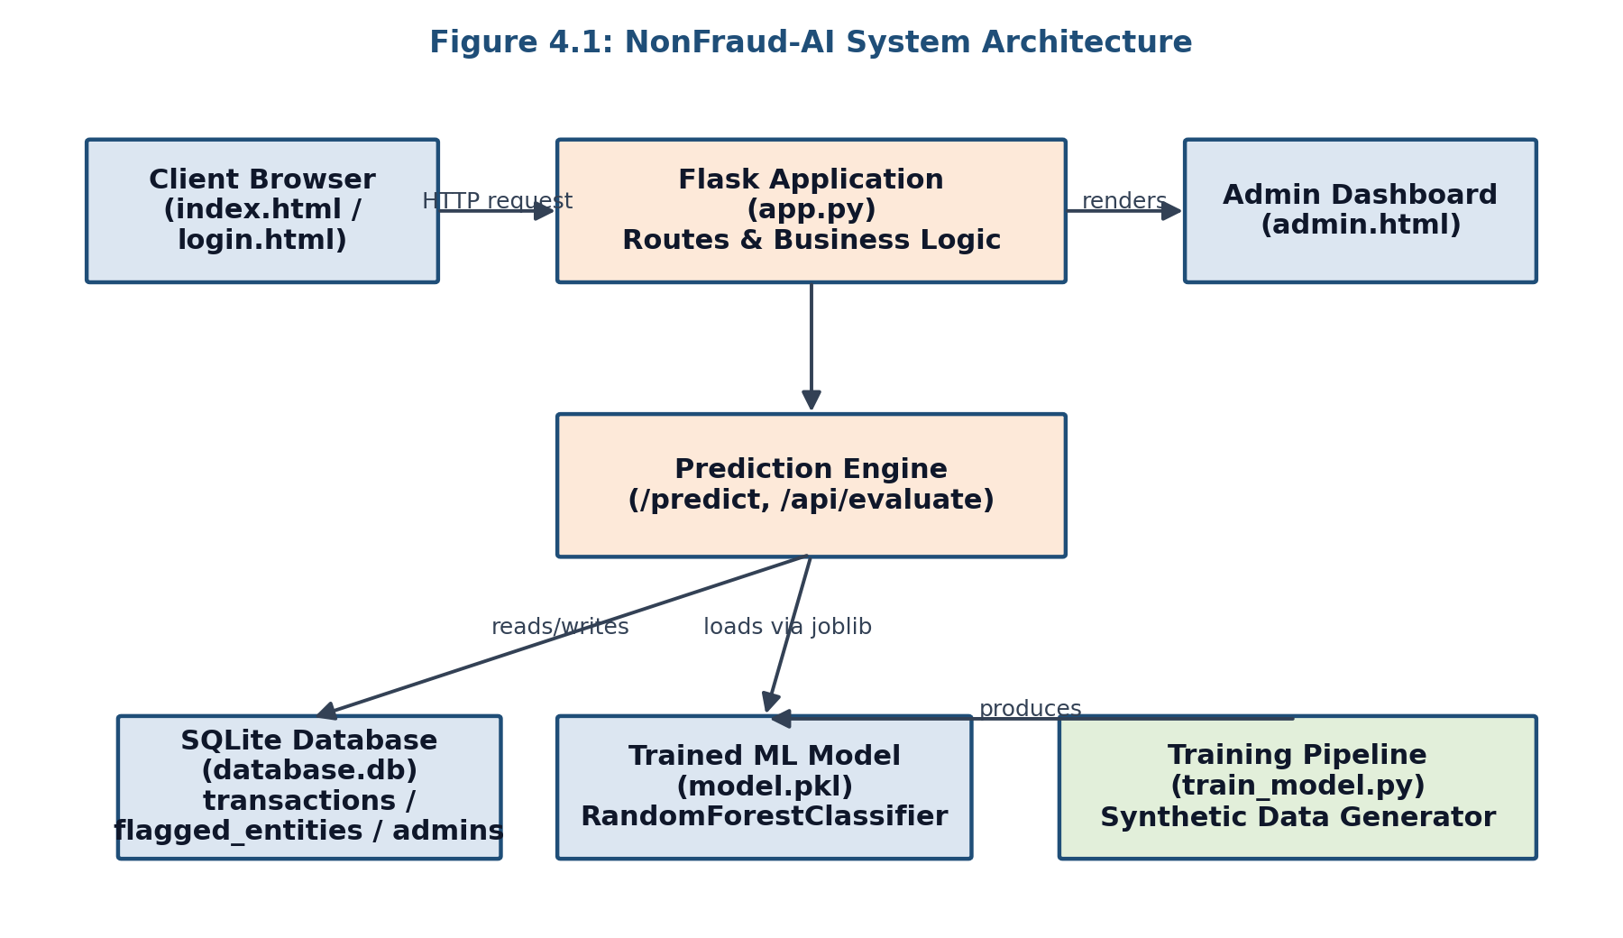
Figure 4.1: NonFraud-AI System Architecture

4.3 Database Design
The database consists of three tables: transactions, which stores every evaluated transaction along with its computed features, risk score, and status; flagged_entities, which stores blacklisted cards and IP addresses; and admins, which stores administrator credentials as salted password hashes. Issuer bank coordinates are held in an in-memory Python dictionary rather than a database table, since this reference data does not change at runtime.
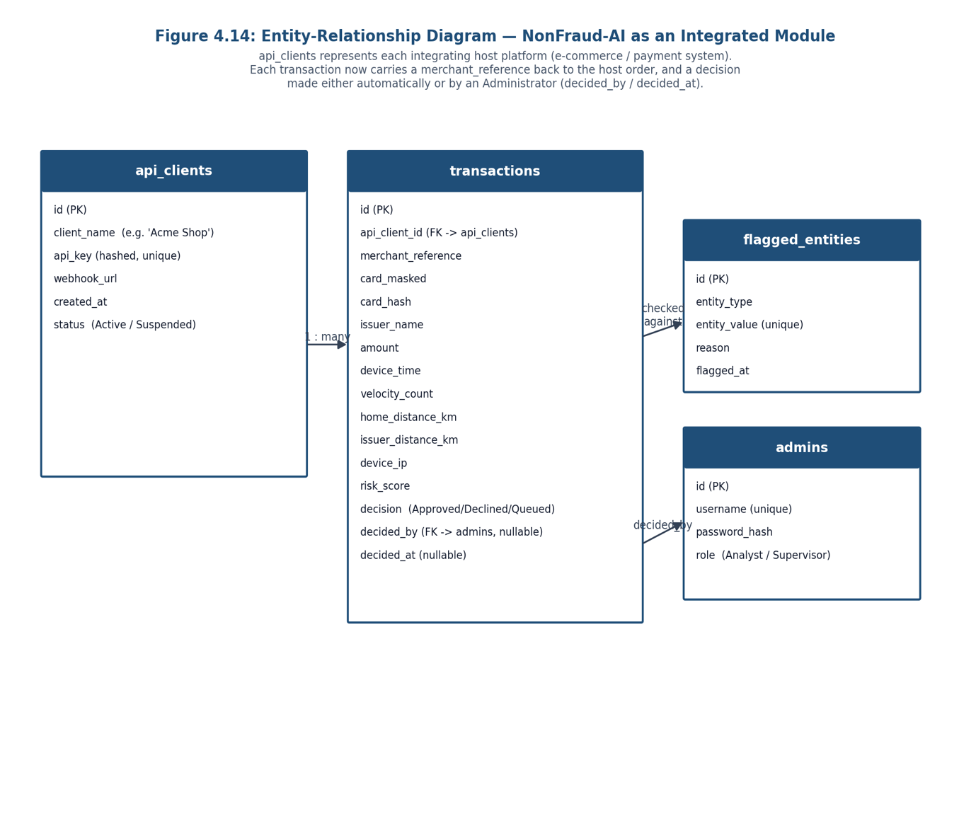
Figure 4.2: NonFraud-AI Database Schema (Entity-Relationship Diagram)
Note: the card_hash column was added during the debugging phase described in section 4.15.4 to uniquely identify a card for velocity calculations, replacing an earlier approach that matched only on the last four digits and issuer name.

4.4 Use Case Design
Two actors interact with the system: the End User, who submits transactions and views the public log, and the Administrator, who reviews, flags, and reports on those transactions. Figure 4.3 presents the consolidated use case diagram; Table 4.1 elaborates each use case.
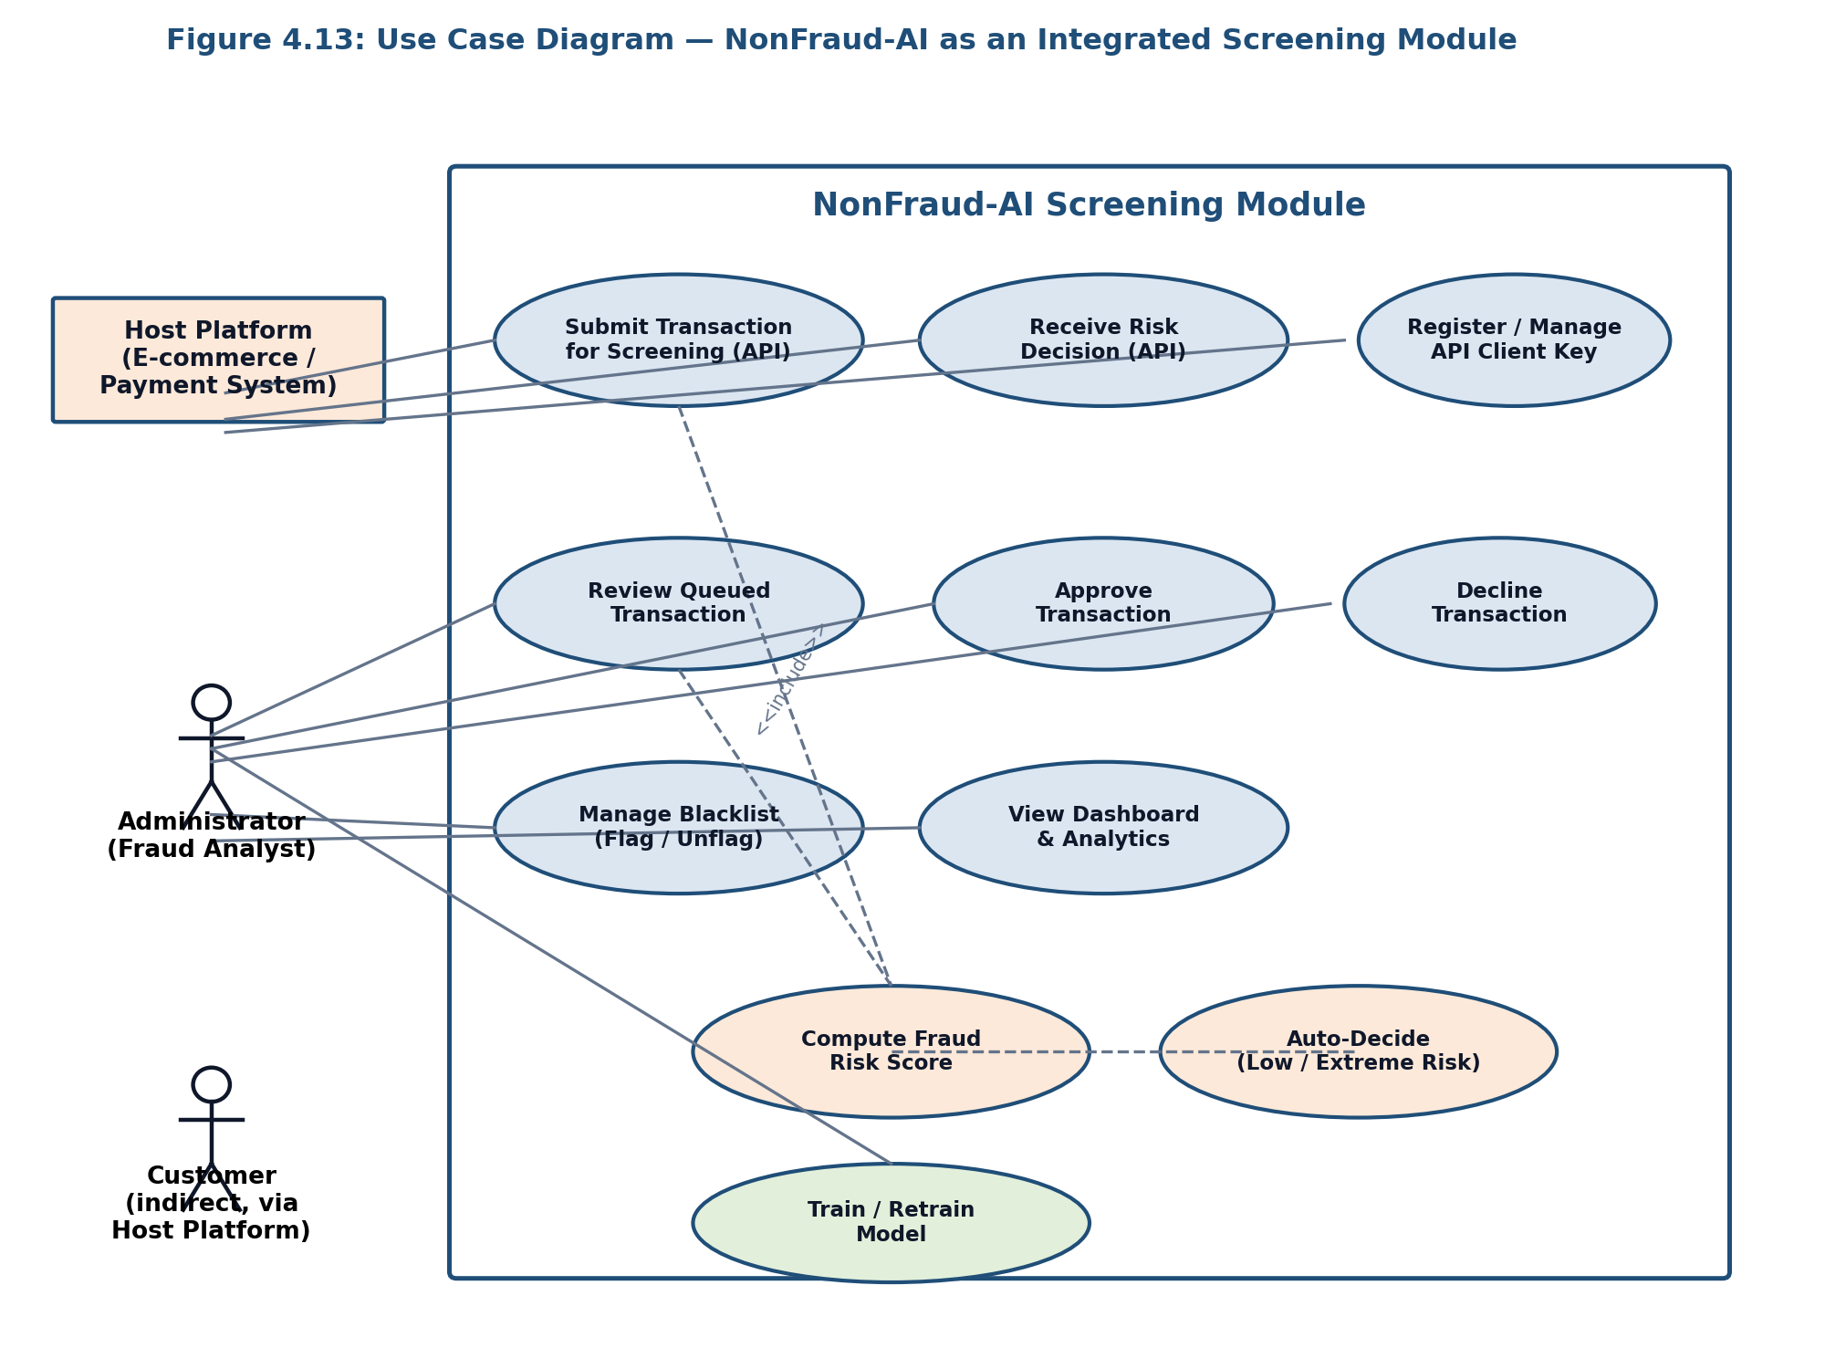
Figure 4.3: NonFraud-AI Use Case Diagram

Use Case | Actor | Description
Submit Transaction | End User | Enters transaction details and receives an immediate fraud risk assessment.
View Transaction Log | End User | Views a running log of previously evaluated transactions.
Admin Login | Administrator | Authenticates with username and password to access the dashboard.
Review Dashboard & Metrics | Administrator | Views transaction metrics, the active blacklist, and a triage log of recent transactions.
Flag / Unflag Entity | Administrator | Adds or removes a card or IP address from the blacklist.
Report Confirmed Fraud | Administrator | Marks a specific transaction as confirmed fraud for record-keeping.
Compute Fraud Risk Score | System | Invoked by both Submit Transaction and Review Dashboard; internally includes the Check Blacklist step.
Train / Retrain Model | Administrator | Runs train_model.py offline to regenerate model.pkl from refreshed synthetic data.

4.5 Fraud Prediction Activity Design
Figure 4.4 presents the activity flow followed by both the /predict and /api/evaluate routes when scoring a transaction, from initial blacklist check through to the final Approved/Flagged decision.
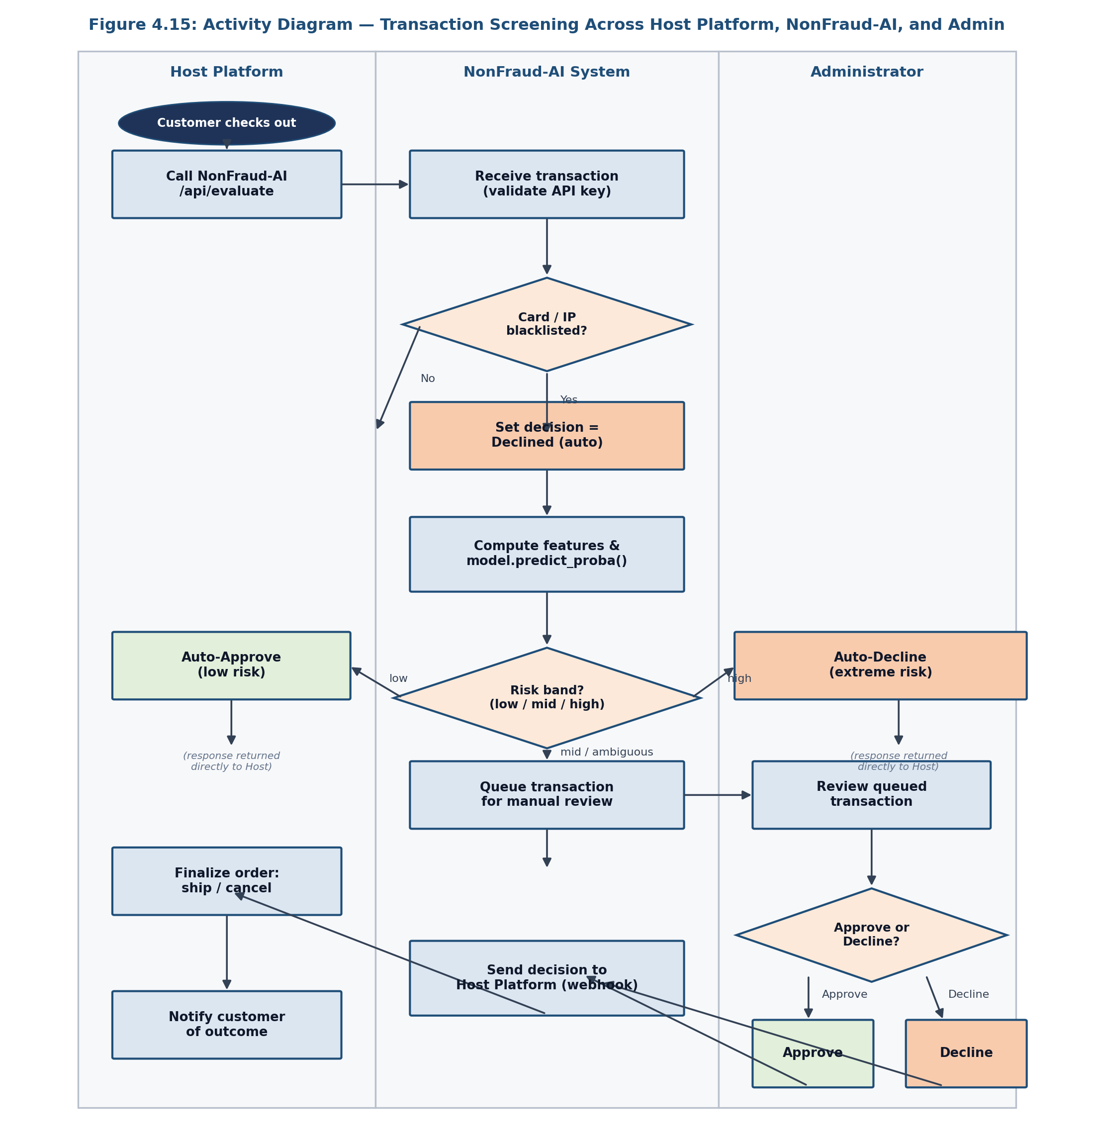
Figure 4.4: Fraud Prediction Activity Diagram

4.6 User Interface Design
The public-facing interface consists of a single-page transaction simulator with a form and a running transaction log. The administrator interface is a separate dashboard reachable only after login, showing summary metric cards, a blacklist management table, and a color-coded transaction triage table. Deliberately, the numerical fraud risk score is shown only on the administrator dashboard and never on the public-facing page, so that a potential fraudster testing the system cannot observe how closely they are approaching the flagging threshold.

4.7 Security Design
- Administrator passwords are hashed with Werkzeug's generate_password_hash and verified with check_password_hash; plaintext passwords are never stored.
- Admin routes are protected by a login_required decorator that checks for an authenticated session before allowing access.
- Full card numbers are never stored in the database in plaintext for lookup purposes; a SHA-256 hash is stored instead, and only the last four digits are retained for display.

4.8 Machine Learning Model Design
The classifier is a scikit-learn RandomForestClassifier (200 estimators, maximum depth 14) trained on five numerical features: log-transformed transaction amount, hour of day, one-hour transaction velocity, distance from the cardholder's home coordinates, and distance from the card issuer's registered location. All five features are computed identically at both training time and inference time a design constraint that was not met in the system's first iteration, and whose correction is discussed in section 4.15.1.

4.9 System Implementation Overview
The application is a single Flask process (app.py) backed by a SQLite database (database.db) and a pre-trained model artefact (model.pkl) produced by a standalone training script (train_model.py). Three Jinja2 templates render the interface: index.html, login.html, and admin.html.

4.10 Implementation of the Transaction Simulation Page
The landing page (index.html) presents a form capturing card number, issuer/bank, expiry date, CVV, and transaction amount. Client-side JavaScript formats the card number into groups of four digits as the user types, validates the expiry date format and rejects already-expired dates, and captures the device's timestamp and, where permitted, its geolocation coordinates via the browser's Geolocation API before submission.
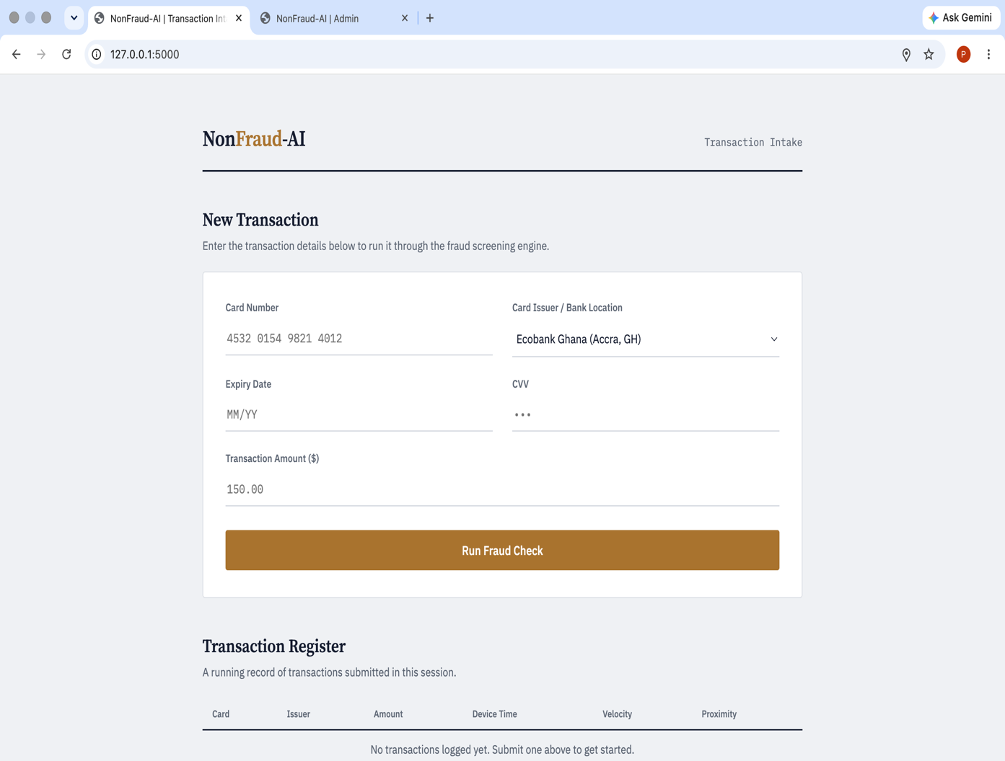
Figure 4.5: Transaction Intake Form

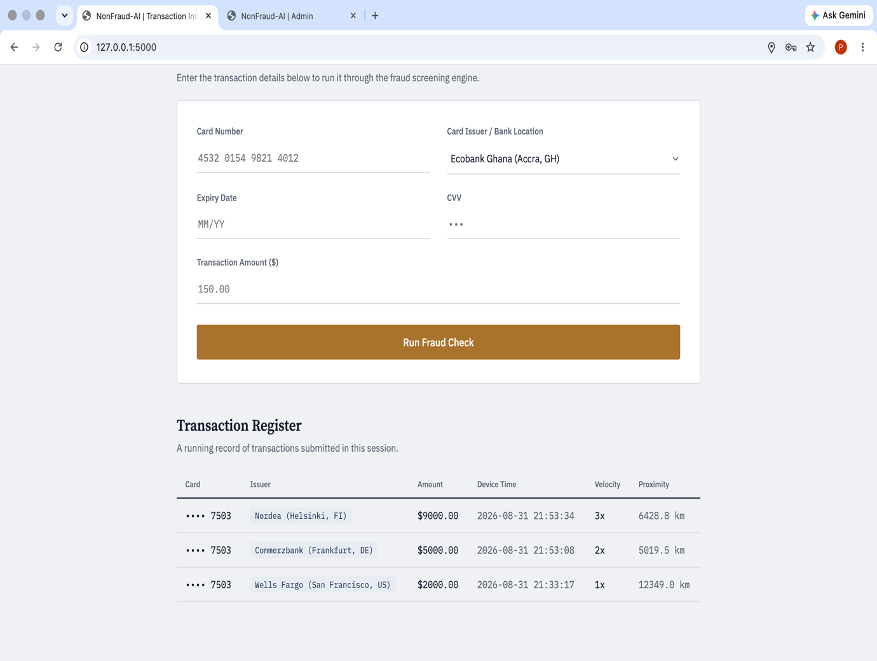
Figure 4.6: Transaction Register

cardInput.addEventListener('input', (e) => {
let value = e.target.value.replace(/\D/g, '');
let formattedValue = '';
for (let i = 0; i < value.length; i++) {
if (i > 0 && i % 4 === 0) formattedValue += ' ';
formattedValue += value[i];
}
e.target.value = formattedValue;
});
Below the form, a Transaction Intelligence Log table lists previously evaluated transactions. The numerical fraud risk score is intentionally withheld from this page, by design (section 4.6).

4.11 Implementation of the Fraud Prediction Engine
Both the form-based /predict route and the JSON /api/evaluate route implement the same core logic, following the activity design in Figure 4.4:
cursor.execute(
'SELECT id FROM flagged_entities WHERE (entity_value=? AND entity_type="Card")'
' OR (entity_value=? AND entity_type="IP")', (card_masked, client_ip))
is_blacklisted = cursor.fetchone() is not None
if is_blacklisted:
fraud_proba = 1.0
else:
scaled_amount = np.log1p(amount)
features = np.array([[scaled_amount, transaction_hour, velocity_count,
home_distance_km, issuer_distance_km]])
fraud_proba = model.predict_proba(features)[0][1]
if home_distance_km > 1000 and amount > 500:
fraud_proba = max(fraud_proba, 0.78)
if amount >= 10000:
fraud_proba = max(fraud_proba, 0.95)

4.12 Implementation of Admin Authentication
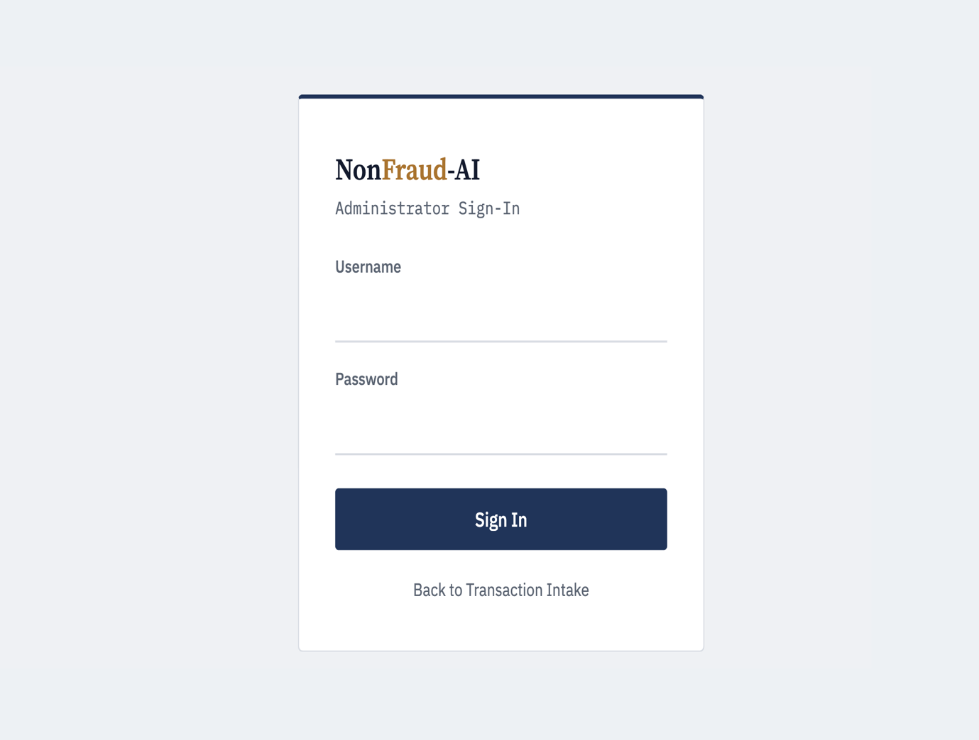
The admin login page (login.html) presents a username/password form. On submission, the server looks up the username in the admins table and verifies the submitted password against the stored hash using check_password_hash. A successful login sets a Flask session flag that subsequent admin routes check via a login_required decorator. A default administrator account (admin / password123) is seeded automatically the first time the database is initialised and should be changed before any real deployment.
Figure 4.7: Admin Sign-In Screen

4.13 Implementation of the Admin Dashboard

4.13.1 Overview and Metrics
Three summary cards show the total number of transactions processed, the number formally reported as fraud, and the number of currently blacklisted entities.
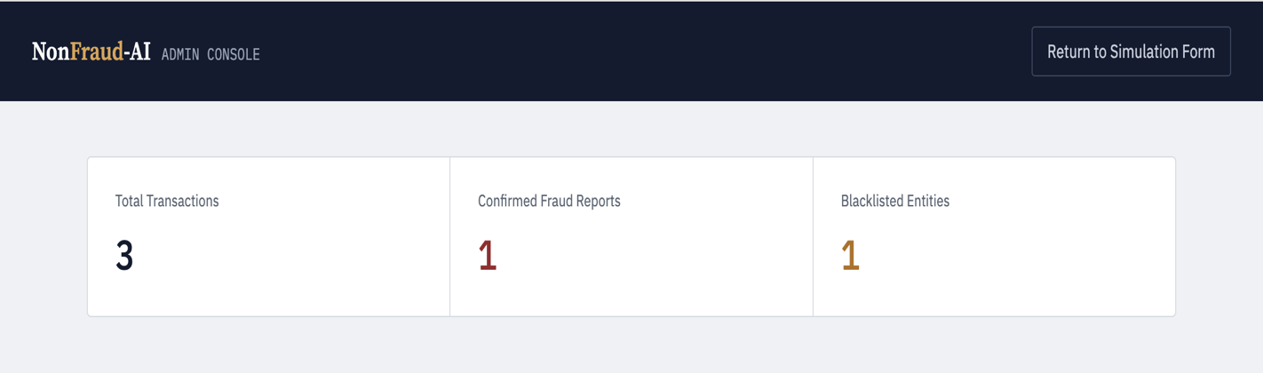
Figure 4.8: Admin Dashboard Metrics

4.13.2 Manual Flagging and Blacklist Management
A form allows the administrator to blacklist a card or device/IP fingerprint with a free-text reason, retained for audit purposes. An Active Blacklisted Entities table lists every currently flagged entity with a one-click Remove Flag action.
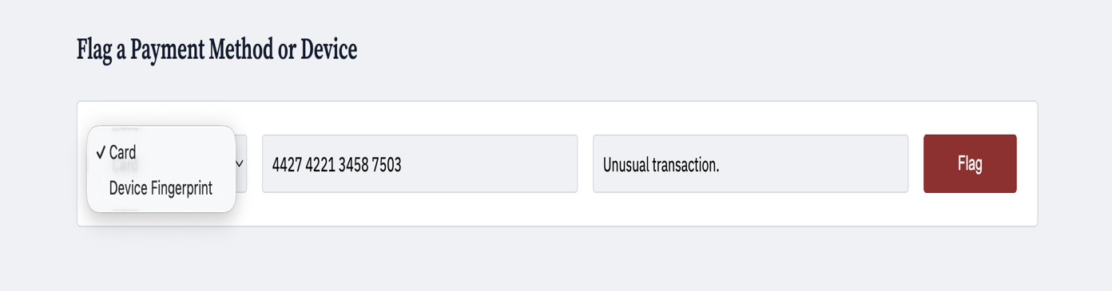
Figure 4.9: Flag a Payment Method or Device Form

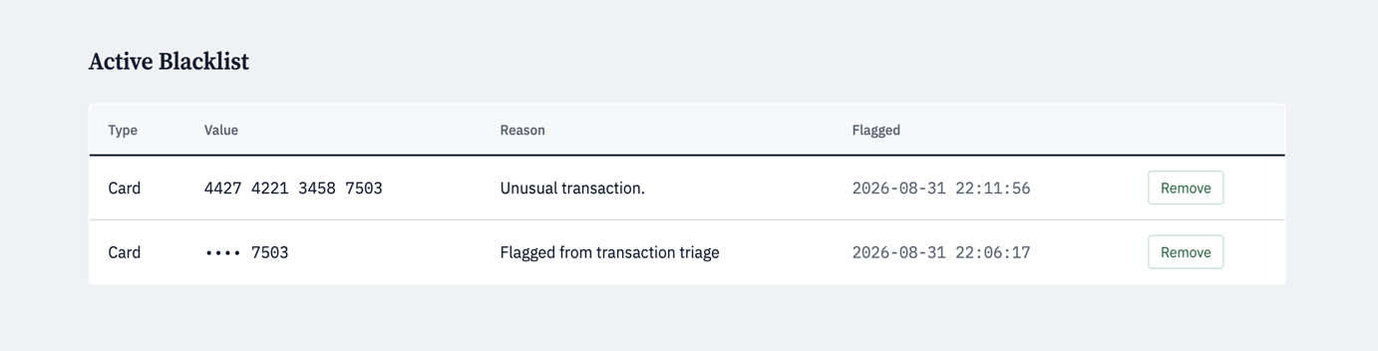
Figure 4.10: Active Blacklist

4.13.3 Transaction Triage Log
A colour-coded table (green through red, scaled to the risk percentage) lists the fifty most recent transactions, allowing the administrator to quickly scan for high-risk activity.

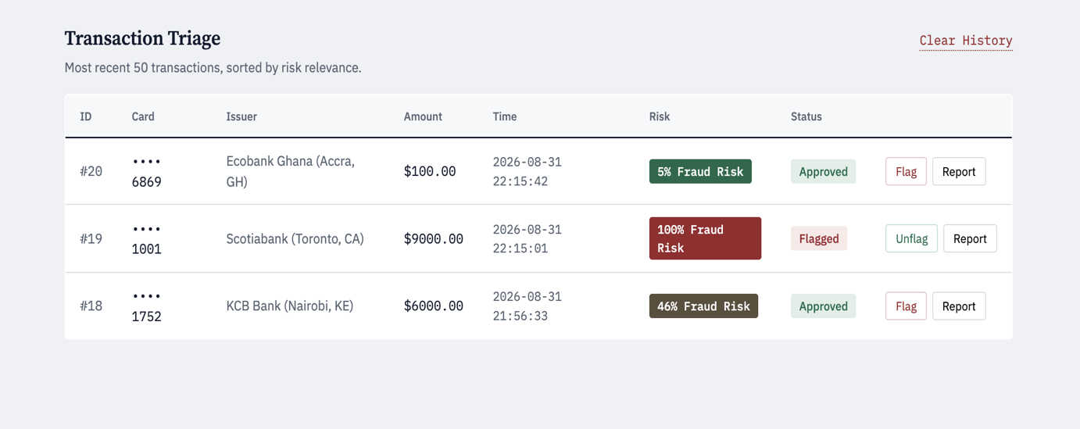
Figure 4.11: Transaction Triage Log

4.14 Implementation of the Model Training Pipeline
Because a real, labelled fraud dataset was not available for this project, the synthetic data generation methodology described in section 3.5 is implemented in train_model.py. A RandomForestClassifier (200 trees, max depth 14) is trained on an 80/20 stratified split and the resulting model is serialised to model.pkl with joblib.
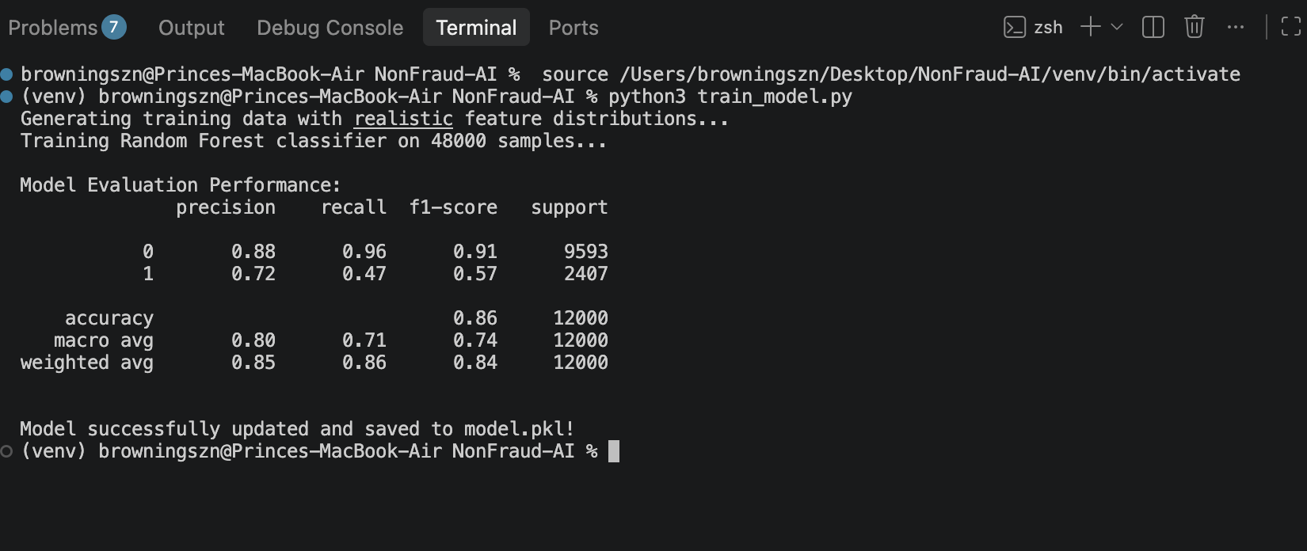
Figure 4.12: Model Training Output (Classification Report)

4.15 Iterative Debugging and Refinement
The first working version of the model produced predictions that were sometimes correct but frequently unconvincing. Diagnosing this required comparing, feature by feature, exactly how each value was generated during training against how the equivalent value was computed at inference time inside app.py. Four distinct issues were identified and corrected, following the debugging methodology of tracing each feature independently through both scripts to find where their computations diverged.

4.15.1 Amount Feature Mismatch
Before: the training generator produced the amount feature as an arbitrary exponential random draw, unrelated to any real currency value.
# BEFORE (train_model.py)
scaled_amounts = np.random.exponential(scale=2.2, size=num_samples)
At inference, however, the application computed this same feature as the natural log of the actual dollar amount entered by the user:
# app.py (unchanged)
scaled_amount = np.log1p(amount)
Because these two quantities were generated by entirely different processes, the model had effectively never been trained on the kind of values it would actually receive in production for medium-to-large transactions. This was corrected by regenerating the training data from a realistic log-normal distribution of dollar amounts and then applying the identical np.log1p transform used in app.py:
# AFTER (train_model.py)
raw_amounts = np.random.lognormal(mean=4.2, sigma=1.3, size=num_samples)
raw_amounts = np.clip(raw_amounts, 1, 50000)
scaled_amounts = np.log1p(raw_amounts) # identical transform to app.py

4.15.2 Distance Feature Gaps
Before: the training generator produced home-distance and issuer-distance values from two disjoint distributions a cluster of small "normal" distances and a separate cluster of very large "clearly fraudulent" distances leaving a gap in the middle (for example, no training examples between roughly 150km and 500km) corresponding to entirely ordinary situations such as a domestic trip.
# BEFORE
home_distances = np.where(np.random.rand(n) > 0.4,
np.random.exponential(scale=40.0, size=n),
np.random.uniform(500, 14000, size=n))
This was corrected by replacing the two-cluster approach with a single continuous log-normal distribution spanning the full realistic range:
# AFTER
home_distances = np.clip(np.random.lognormal(mean=3.3, sigma=1.9, size=n), 0, 20000)

4.15.3 Hard Probability Cliff
Before: the original label-assignment rule applied a hard cutoff any synthetic transaction with a composite risk score at or above 0.45 was labelled fraudulent with 85% probability, and anything below that threshold with only 3% probability, producing a model that had effectively learned a step function.
# BEFORE
if risk_score >= 0.45:
fraud_labels[i] = 1 if np.random.rand() < 0.85 else 0
else:
fraud_labels[i] = 1 if np.random.rand() < 0.03 else 0
This was replaced with a smooth logistic function mapping the composite risk score to a fraud probability, removing the artificial discontinuity:
# AFTER
def true_fraud_probability(velocity, home_dist, issuer_dist, scaled_amount):
risk_score = (0.10*np.minimum(velocity-1,6) + 0.35*np.minimum(home_dist/2000,1)
+ 0.30*np.minimum(issuer_dist/2500,1) + 0.25*np.minimum(scaled_amount/9.5,1))
return 1/(1+np.exp(-8*(risk_score-0.5)))

4.15.4 Velocity Calculation Collision Bug
Before: the velocity feature was computed by matching on the card's last four digits together with the issuer name. Because many different cards from the same issuer can share the same last four digits, this caused unrelated customers' transactions to be counted together.
# BEFORE
cursor.execute('SELECT device_time FROM transactions WHERE card_masked LIKE ? AND issuer_name = ?', (f"%{last_four}", issuer_name))
This was corrected by introducing a card_hash column (a SHA-256 hash of the full card number) and matching on that value instead:
# AFTER
card_hash = hashlib.sha256(raw_card.encode()).hexdigest() if raw_card else ""
cursor.execute('SELECT device_time FROM transactions WHERE card_hash = ?', (card_hash,))
Together, these four corrections addressed both the model's statistical calibration (sections 4.15.1-4.15.3) and a data-integrity bug in feature computation (section 4.15.4), and materially improved the coherence of the risk scores the system produces.

4.16 System Testing

4.16.1 Unit Testing
Test ID | Description | Input | Expected Output | Result
UT-01 | Haversine distance, identical points | (5.6037,-0.1870) to itself | 0.0 km | Pass
UT-02 | Haversine distance, known pair | Accra to Lagos coordinates | ~430-450 km | Pass
UT-03 | Card masking, valid input | "4532015498214012" | "•••• 4012" | Pass
UT-04 | Card masking, short input | "12" | "•••• 0000" (fallback) | Pass

4.16.2 Integration Testing
Test ID | Scenario | Expected Result | Result
IT-01 | Submit a small, local transaction | Low risk score; status Approved; row inserted into transactions | Pass
IT-02 | Submit a transaction on a blacklisted card | risk = 100%; status Flagged, regardless of other features | Pass
IT-03 | Submit five rapid transactions on the same card | velocity_count increments correctly on each subsequent submission | Pass

4.16.3 System Testing
The complete workflow was tested end-to-end: a simulated transaction was submitted as an end user, then reviewed, flagged, and reported as an administrator, confirming that the two halves of the application remain consistent with one another and that the database correctly reflects actions taken from either interface.

4.16.4 Security Testing
Test ID | Check | Result
ST-01 | Unauthenticated request to /admin redirects to /admin/login | Pass
ST-02 | Stored admin password is a salted hash, not plaintext | Pass
ST-03 | Full card number is not retrievable from the database (only hash and last 4 digits stored) | Pass

4.16.5 User Acceptance Testing (UAT)
[Describe here any informal review carried out with your supervisor or peers for example, walking through the admin dashboard together and noting feedback received and any resulting changes.]

4.17 System Evaluation

4.17.1 Evaluation Metrics
The retrained model was evaluated on a held-out 20% test split using precision, recall, and F1-score for both classes, per the methodology set out in section 3.9.
(See Figure 4.12 for the model's classification report.)

Class | Precision | Recall | F1-score
Legitimate (0) | 0.88 | 0.96 | 0.91
Fraudulent (1) | 0.72 | 0.46 | 0.57
Overall Accuracy | - | - | 0.86

4.17.2 Performance Evaluation
The model achieves strong precision and recall on legitimate transactions, meaning genuine transactions are rarely wrongly flagged. Recall on the fraudulent class (0.46) indicates the model still misses a substantial share of fraudulent transactions in this synthetic setting, which is expected given that fraud detection is inherently an imbalanced classification problem, and which section 5.5 identifies as a direction for further improvement.

4.18 Chapter Summary
This chapter has presented NonFraud-AI's system design its architecture, database, use cases, prediction activity flow, interface, security, and model design, each illustrated with a diagram followed by its implementation page by page, the step-by-step debugging narrative that materially improved prediction quality, and the results of testing and evaluating the completed system. The following chapter discusses the overall outcome of the project against its stated objectives.

CHAPTER FIVE

CONCLUSION AND RECOMMENDATIONS

5.1 Introduction
This final chapter reflects on the extent to which the project's stated objectives were achieved, summarizes the key achievements and challenges encountered during development, and offers recommendations for future work.

5.2 Discussion

5.2.1 Achievement of Objective One (Model Design)
A Random Forest classifier was successfully designed and trained on five transaction-level features. Its initial version suffered from training-serving skew and mislabelled boundary cases, both of which were diagnosed and corrected, as documented in section 4.15.

5.2.2 Achievement of Objective Two (Web Application)
A complete Flask application was implemented, providing both a public transaction simulator and a form-based JSON API for programmatic scoring, satisfying the requirement for real-time evaluation.

5.2.3 Achievement of Objective Three (Administrative Dashboard)
A functioning administrator dashboard was implemented supporting transaction triage, manual flagging and unflagging, and formal fraud reporting, with corrected color-coding that accurately reflects each transaction's underlying risk score.

5.3 Key Achievements
- Successfully identified and corrected a training-serving skew bug affecting the amount feature.
- Replaced a collision-prone velocity-matching approach with a secure, collision-free card-hash-based approach.
- Delivered a complete, end-to-end working prototype covering data generation, model training, real-time inference, and an administrative review workflow, supported by a full set of design diagrams.

5.4 Challenges Encountered
- Absence of a real, labelled fraud dataset required building a synthetic data generator, which introduced its own risk of not matching real-world feature distributions.
- Diagnosing the root cause of unreliable predictions required tracing each feature independently through both the training script and the live application to find where their computations diverged.
- [Add any additional challenges specific to your own experience.]

5.5 Recommendations

5.5.1 Integration with Real Payment Gateways
A production version of this system would need to integrate with an actual payment processor's transaction stream rather than a simulated form.

5.5.2 Mobile Application
A companion mobile app for administrators could provide push notifications for high-risk transactions requiring immediate review.

5.5.3 Advanced Notification System
Email or SMS alerts could be added so administrators are notified in real time when a transaction is flagged.

5.5.4 Improved Analytics
Additional dashboard visualizations (fraud trends over time, geographic heat maps of flagged transactions) would aid pattern recognition beyond individual transaction review.

5.5.5 Enhanced Security
A production deployment should enforce a strong default administrator password policy, rate-limit login attempts, and move the Flask secret key out of source code and into an environment variable.

5.5.6 Cloud Deployment
Migrating from SQLite to a managed cloud database and deploying behind a WSGI server would be necessary to support concurrent users at scale.

5.5.7 Further Model Improvement
Future work could explore a larger and more diverse synthetic dataset, alternative algorithms (gradient boosting), threshold tuning to improve fraud-class recall, and, where a real dataset becomes available, retraining and validating against it.

5.6 Conclusion
NonFraud-AI demonstrates that a hybrid rule-and-machine-learning approach to fraud detection can be built, tested, and meaningfully improved using freely available tools within the scope of a final year project. Beyond the working system itself, the debugging process documented in section 4.15 tracing a real-world prediction quality problem back to a mismatch between training and serving data reflects a practically important skill in applied machine learning that extends well beyond this specific project.

APPENDICES

APPENDIX A: USER MANUAL

A.1 Introduction
This appendix provides step-by-step instructions for running and using NonFraud-AI.

A.2 Running the Application
# 1. Install dependencies
pip install flask scikit-learn joblib numpy pandas werkzeug
# 2. Train the model (creates model.pkl)
python train_model.py
# 3. Run the application
python app.py
# 4. Open in browser
http://localhost:5000

A.3 End User Guide

#To screen a transaction, the host platform sends a POST request to:

/api/evaluate

#With a JSON body containing: card_number, issuer_name, amount,

latitude, longitude

#The response returns: risk_score_percentage, action (ALLOW/BLOCK),

and status

A.4 Administrator Guide
- Navigate to /admin/login and sign in (default credentials: admin / password123 change before any real deployment).
- Review the metrics cards, blacklist table, and colour-coded transaction triage log.
- Use the Flag/Unflag buttons to manage the blacklist, and the Report button to formally record confirmed fraud.

APPENDIX B: SAMPLE CODE LISTINGS

B.1 Haversine Distance Function
def haversine(lat1, lon1, lat2, lon2):
r = 6371 # Earth radius in km
lat1, lon1, lat2, lon2 = map(radians, [lat1, lon1, lat2, lon2])
dlat = lat2 - lat1
dlon = lon2 - lon1
a = sin(dlat/2)**2 + cos(lat1) * cos(lat2) * sin(dlon/2)**2
return 2 * r * asin(sqrt(a))

B.2 Database Schema Initialization
CREATE TABLE IF NOT EXISTS transactions (
id INTEGER PRIMARY KEY AUTOINCREMENT,
card_masked TEXT NOT NULL, card_hash TEXT DEFAULT '',
issuer_name TEXT NOT NULL, amount REAL NOT NULL,
device_time TEXT NOT NULL, velocity_count INTEGER NOT NULL,
home_distance_km REAL NOT NULL, issuer_distance_km REAL NOT NULL,
device_ip TEXT DEFAULT '127.0.0.1', prediction TEXT NOT NULL,
status TEXT DEFAULT 'Pending'
);

APPENDIX C: REQUIREMENTS GATHERING INSTRUMENT
The following self-directed question set was used to elicit and check requirements
against the identified actors (Host Platform and Administrator), in the absence of
a live client.

● What information does the host platform need to provide via the API before a
transaction can be evaluated?
● What is the minimum information an administrator needs to see to decide whether
to investigate a transaction further?
● What actions should an administrator be able to take directly from the triage
log, without navigating to a separate page?
● Which pieces of information (for example, the numeric risk score) should be
withheld from the host platform's API response, and remain visible only to
administrators internally?
● What would constitute an unambiguous case that should be auto-declined
regardless of the model's own prediction, without requiring admin review?

REFERENCES
Cherif, A., Badhib, A., Ammar, H., Alshehri, S., Kalkatawi, M., & Imine, A. (2023). Credit card fraud detection in the era of disruptive technologies: A systematic review. Journal of King Saud University - Computer and Information Sciences, 35(1), 145–174. https://doi.org/10.1016/j.jksuci.2022.11.008

Johnson, J. M., & Khoshgoftaar, T. M. (2019). Survey on deep learning with class imbalance. Journal of Big Data, 6(1), Article 27. https://doi.org/10.1186/s40537-019-0192-5

Kalid, S. N., Ng, K.-H., Tong, G.-K., & Khor, K.-C. (2020). A multiple classifiers system for anomaly detection in credit card data with unbalanced and overlapped classes. IEEE Access, 8, 28210–28221. https://doi.org/10.1109/ACCESS.2020.2972009

Maria, E., Budiman, E., Haviluddin, & Taruk, M. (2020). Measure distance locating nearest public facilities using Haversine and Euclidean methods. Journal of Physics: Conference Series, 1450(1), Article 012080. https://doi.org/10.1088/1742-6596/1450/1/012080

Marazqah Btoush, E. A. L., Zhou, X., Gururajan, R., Chan, K. C., Genrich, R., & Sankaran, P. (2023). A systematic review of literature on credit card cyber fraud detection using machine and deep learning. PeerJ Computer Science, 9, Article e1278. https://doi.org/10.7717/peerj-cs.1278

Paleyes, A., Urma, R.-G., & Lawrence, N. D. (2022). Challenges in deploying machine learning: A survey of case studies. ACM Computing Surveys, 55(6), Article 114. https://doi.org/10.1145/3533378

